Coffee Business
Student’s Name
Institutional Affiliation

Coffee Business
The Vistabean coffee chain is distributed across the different states in the US. Most of the stores are a major market, and the concentration of the stores varies across the states. For instance, they are densely populated in the states of Texas, California, and Ohio and moderately distributed in Utah and New Mexico among others.
Figure 1; the Geographical spread of the coffee chain stores
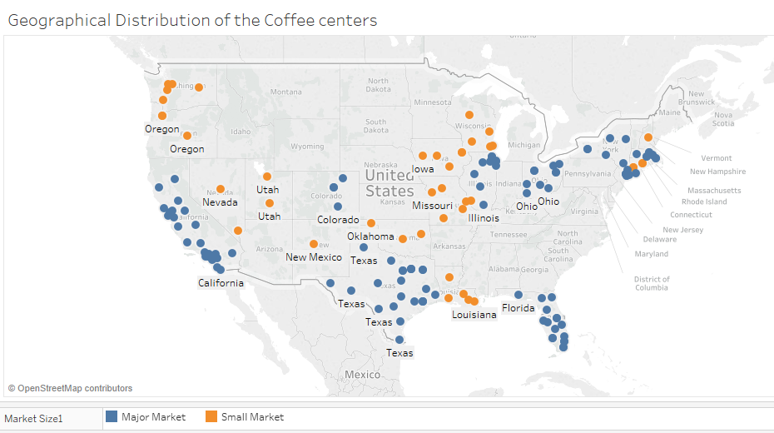
Product portfolio
The Coffee chain portfolio has four product types: Coffee, Tea, Espresso and Herbal Tea. There are further two categories which are Beans and Leaves. The Beans category is comprised of Coffee and Empress while Tea and Herbal Tea fall at the Leaves category. Breaking the pact further indicates that the chain offers 13 products depending on the different variety from the four product types.
Figure 2: Product Portfolio
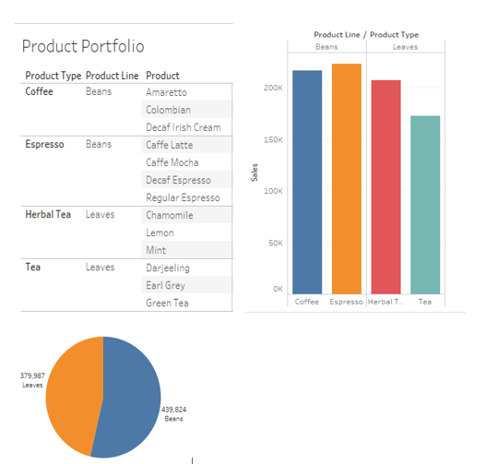

Considering the overall sales according to the product line, Beans have a higher percentage of the market share compared to the leaves. For the beans, Espresso made higher sales than Coffee while for the Leaves, Herbal tea sales were higher than that of Tea.
Product Sales
The products performed differently at the market. The following is a first glance of the different performances that would help identify the underperforming items.
Figure 3; product sales
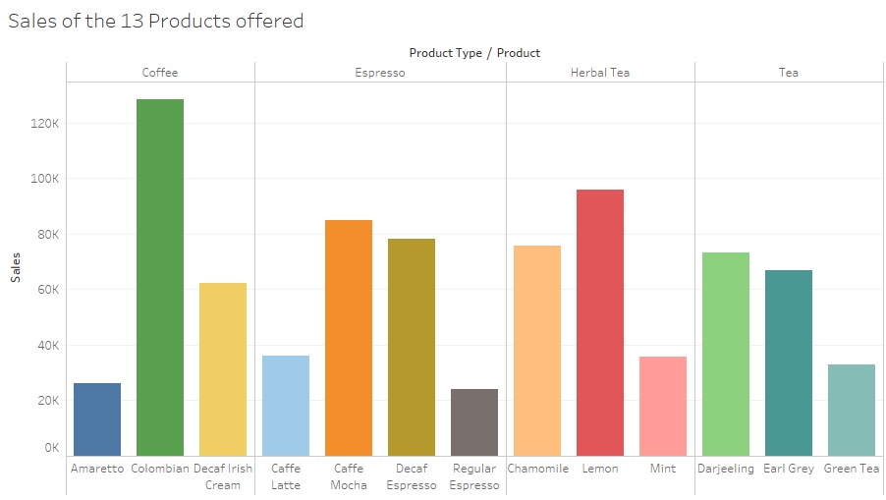
From the Figure 3 above, the underperforming items out of the 13 offered by the chain were Amaretto under Coffee category, Regular Espresso and Caffe Latte under Espresso, Mint under Herbal Tea and Green Tea under Tea category. However, further analysis is needed to establish if the items with the lowest profit and determine if they are the same that recorded low sales. Deriving from Figure 4 below, the four items listed above that made the lowest sales still made the lowest profits with the addition of Caffe Mocha under the Espresso category that also recorded low profits despite the high sales.
Figure 4
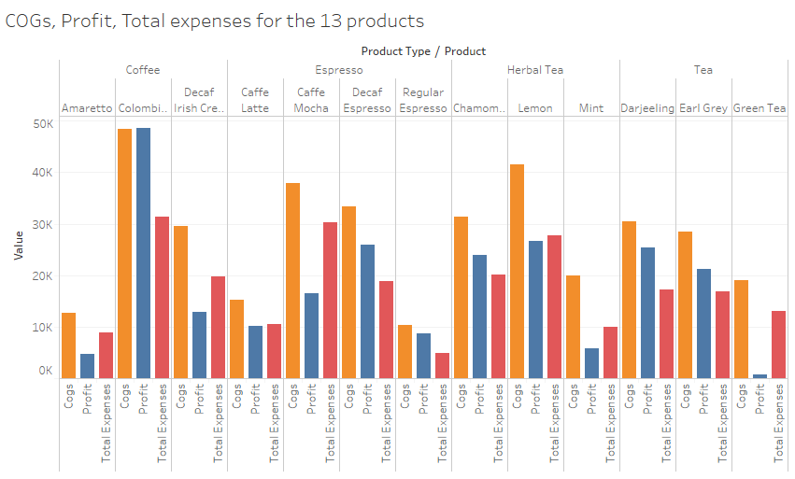
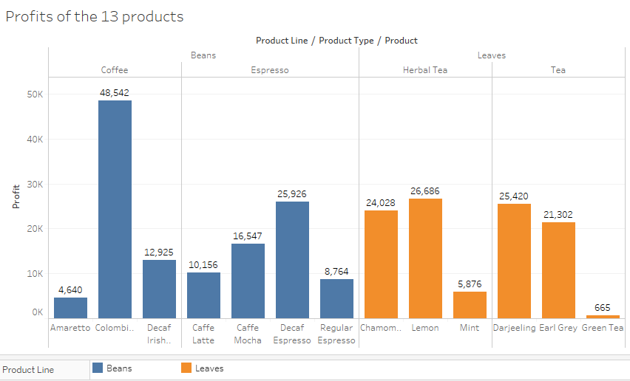
Company Strategy
Vistabean should consider reviewing its products based on the profits they generate instead of the quantities sold. Based on the analysis above, Espresso was the most affected where despite making relatively similar sales with Tea, the profits were less. It is therefore important for the company to review the products and identify those making loss or insignificant profits compared to the sales made. Such products should be eliminated from the process, but the process should consider regional parity and elimination be conducted on areas generating losses.
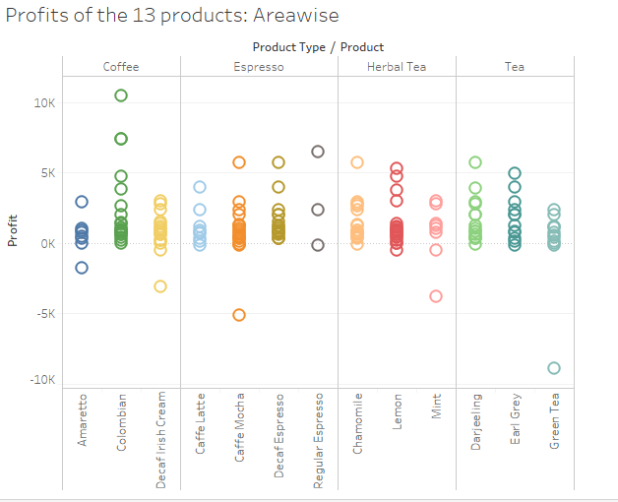

Conclusion and recommendations
Recommendation 1
The marketing strategy used by the company has reflected in the profits gathered for instance for Colombian and Chamomile, but a negative disparity for other products was observed. In one scenario, Green Tea showcased the highest disparity given the high marketing spends allocated on it and the low returns. Overall, the company should minimize its marketing spending by seeking alternative ways requiring minimal spending for the products with high negative disparities — for example, discounts for recurring customers and encouragement of referrals.
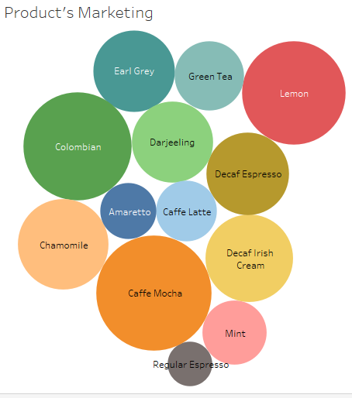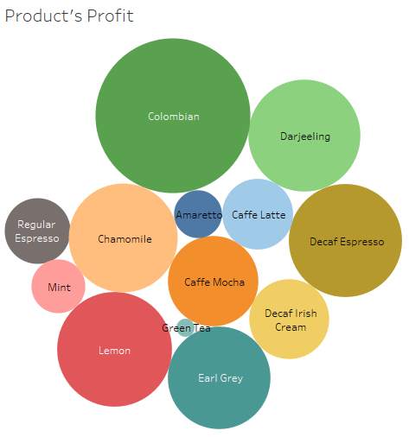
Recommendation 2
The consumption of Beans and Leaves products varies depending on the season. For instance, normally, Beans are on higher demand than leaves during autumn. Therefore, in the review on the elimination of some products, the season element should be considered and maybe the supply of the underperforming products should be confined during peak seasons. The item that should be reviewed is Amaretto, Regular Espresso, Caffe Latte, Mint, Green Tea and Decaf Espresso. Depending on the season for which the data was collected, the overall decision should consider the season influence.
Recommendation 3
From the analysis, the company should review the following items in the specified areas, among others
- Amaretto in California and Oregon
- Decaf Irish Cream in California and New Mexico
- Caffe Latte in New Mexico and Louisiana
- Caffe Mocha in New York, Massachusetts, and Connecticut
- Regular Espresso in New Hampshire
- Mint Herbal Tea in Utah and New York
- Green Tea in Utah, Nevada, and Missouri
The states with the lowest profit records implying low performance should be dropped. They are the regions that recorded massive losses despite the existing marketing efforts; they include sales of Caffe Mocha and Mint in New York. Strategies to maintain the trends in the high performers should be maintained to avoid declines.
Recommendation 4
The cost of the goods sold and the expenses should be reviewed as an increase in either result to low profits. In figure 3 and 4, the sales and profit trends differed for the products which imply that high sales do not always guarantee high profits. For instance, in figure 3, the sales for Caffe Mocha were higher than those of Decaf Espresso, but when profits were considered, the case was reversed. The difference can only be attributed to the higher costs and expenses. Therefore, the management should put strategies to minimize the overall deductions made from the sales.
In conclusion, whenever possible, the company should ensure product promotion for underperforming products. Otherwise, the products should be cut off from the affected areas and instead reverted to the performing regions.

